Lab 3: Free Fall Motion
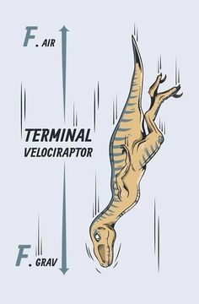

Overview:
This lab is going to serve as test to see how much you have learned as a programmer thus far. This program will focus more on stuff you have already learned such as loops and updating positions of objects. This program will also introduce two new programming concepts: functions and graphs. For this lab, you will write your own function for gravitational potential energy and kinetic energy. Concepts that will be vitally important to this lab are kinetic and potential energy. Below, I have included an image that should help us review some energy concept for this lab!
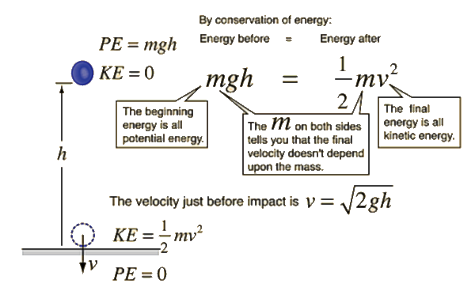
Part 1: Tutorial
For this lab, you will watch one video and read one webpage to reinforce and review our in-class programming demo. Just like the previous labs, you will summarize the video, one paragraph in length, and take note of any tips or important syntax highlighted by the video author. For the web page on graphs, you will write a one paragraph summary about the information on that page.

Functions: https://www.youtube.com/watch?v=Qa5DDqzHh3g
This video can also be found via google search for "Pyhton: defining functions" by Brown.

Graphs: http://vpython.org/contents/docs/graph.html
This is just a webpage of information

Don't worry too much about getting down all the information about making real time plots in vPython. I will include most of the graphing code on this handout, but you will be on your own for the rest of the code.

Part 2: Practice with Functions
For this section of the lab, we are going to practice writing a few simple functions. Below I will write a sample function that will return the number squared.

def squared (x):
x = x*x
return x

As shown above, we start with "def" followed by the function name. After the name, the parenthesis contain the type of argument that can be passed. Then, the logic, similar to a loop, is placed inside the function. Lastly, you see the word return followed by x. That line indicates what the function returns when used.

Now that you have seen a simple function, copy the above code, change the function name to halved and modify it slightly to return the number divided by two. Then to test your function, add this code to the program below and compile.

print halved(158)

The result should be 79. If you did not get this result, repeat this section. Do not move on until you understand part 2.

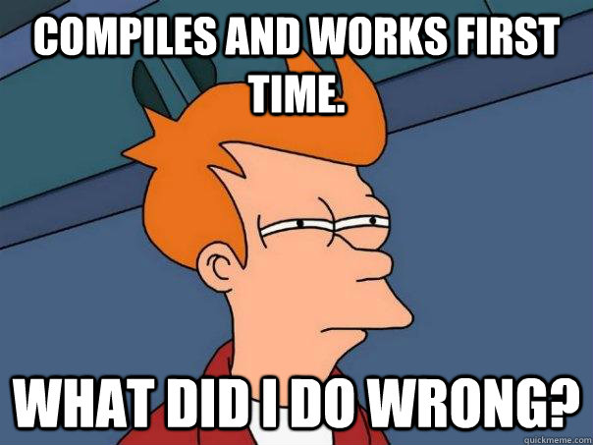
Part 3: Free Fall Simulation
For this part of the lab, you will write most of this program by yourself. I will give you a template of comments to copy and paste before you start. These comments will help guide you in writing the program. I will also include most of the code for a potential and kinetic energy graph. You will need to fill in the attributes to make the two graphs work. I will also include a third graph, for total energy, but I will provide the complete code for that graph as an example.

When coding your values for positions, make sure to use the vector notation I highlighted in class. For example, the height you will drop the object from will be 50 meters. You would not program this as h = 50.0, you would program h as h = vector(0, 50, 0). This will allow you to use the dot product that we also reviewed. When you multiply two vectors in python, you have to use this notation:

numpy.dot(vector 1 goes here, vector 2 goes here)

and not this notation

v*v

If you try to use the simple multiplication notation, you will receive errors during compilation. Lastly, before you begin, don't forget to use your previous lab assignments as a reference. All the logic needed to complete this assignment, aside from the graph code provided here, can be seen in your other programs.

Here is the code and comments you will use:

from __future__ import division
from visual import*
from visual.graph import*
import numpy
#above are the libraries you will need for this program. I have included them
#for you.

#Below define the mass as 0.5 and an acceleration vector that points only in
#the y direction at -2.0 m/s^2
m =
a =

#Write two functions for PE and KE. Hint: use the numpy.dot(x,y) operation only
#once in each definition.
def PE(y):
pe =
return pe

def KE(v):
ke =
return ke

#Define a position and velocity vector as well as time. Time starts at zero,
#the object has zero velocity and the initial position is 50 meters above
#ground.
h =
v =
t =

#Below you need to code two object, a flat sheet for the ground and a ball
#that will drop. The radius of the ball should be 1.0 and the size of the sheet
#should be 20x20x2. Lastly, the sheet should be at the origin and the ball
#should be 50 m above the sheet
ball =
track =

#This is the code for the graphs that I have included, do not modify this code.
Kgraph = gcurve(color = color.red)
Ugraph = gcurve(color = color.blue)
KplusUgraph = gcurve(color = color.magenta)

#This is the loop you will program. Run the loop for 7 seconds and increment
#the time by 0.1 seconds. Don't forget to increment the velocity as well. The
#way you can increment velocity is using the equation vf = vi + at. I set the
#rate already, so don't modify that. I have included most of the code for your
#graphs. You must add the missing components to make the graphs work. Hint: use
#your functions somehow to update the graphs.
while t < 7.2:
rate(50)
ball.pos =
#Kinetic Energy plot, make sure to replace the XXXXXX term
K =
Kgraph.plot(pos = (t,XXXXXX))
#Potential Energy Plot, make sure to replace the XXXXXX term
U = PE(ball.pos)
Ugraph.plot(pos = (t,XXXXXX))
#Total Mechanical Energy Plot
KplusUgraph.plot(pos = (t, K + U))
v =
t =

Once you complete your code and can run the simulation, please save your program as lab3part3 in you master folder. You will submit it to me during one of our lab classes.

